**Quora React Development Diary**

This is a Quora React development diary. Here you can read and view the progress from the first day to last day of development.

**26/08/2022**

On the first day, I only create a navigation bar that include Quora name and icon menus. For the icon, I use tooltip from Material UI to display a specified information of certain element. I have trouble with babel caching configuration.

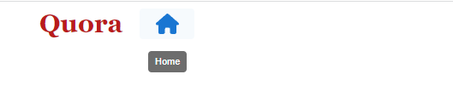

**Progress 1 Logo and Icon on Navbar**

**28/08/2022**

I have successfully created a navbar with icon tooltip. They also can change color if being selected. I use useState to store selected value on each icon to change style. I will make an search input and probably can finish the navbar.

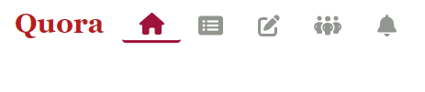

**Progress 2 Default Page**

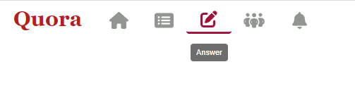

**Progress 3 Icon Style Change If Selected**

**03/09/2022**

I have made a search bar that can change its width when clicked on. Before I click the search bar, there are 3 button on the right side of the search bar which are Try Quora+, profile, and language. After I clicked the search bar, the bar will change its width to overlap those three buttons. And I have made Add Question button. This navbar need a little improvement.



**Progress 4 Navbar Current Appearance**

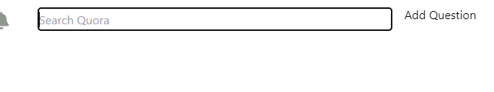

**Progress 5 When search bar is being clicked on**

**04/09/2022**

I made a great improvement on my navigation bar. The search input field can go back to its original size when I click on the main page, which is under the navigation bar. The profile picture updated to my picture I got from internet. On the right side of navigation bar, there are 2 buttons which are add button and chevron-down icon. If I click one of them, they will show a modal from their respective function.

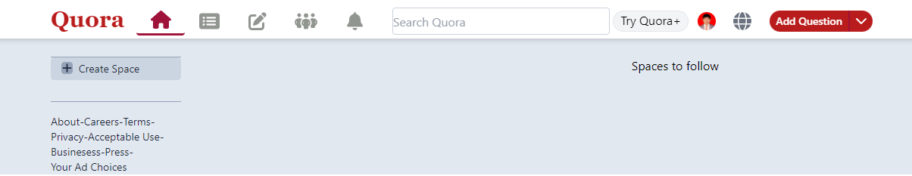

**Progress 6 Update on Navigation Bar and Main Page**

On this picture below is a div that contain a button to make spaces, and below it will be a display of recorded spaces. And the bottom of it is basically a footer of this div.

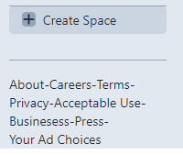

**Progress 7 Create Space Div**

For the backend, I haven’t made any because I’m still working on Quora ERD.

**05/09/2022**

Today, I don’t really work much on frontend, but I have added a bunch of buttons on the center of the page and space to follow on the left side of the page.

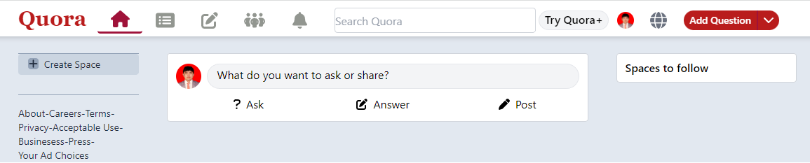

**Progress 8 Current Home Page**

I have worked on database and I use PostgreSQL. There are 5 table I have made and I might modify my database later.

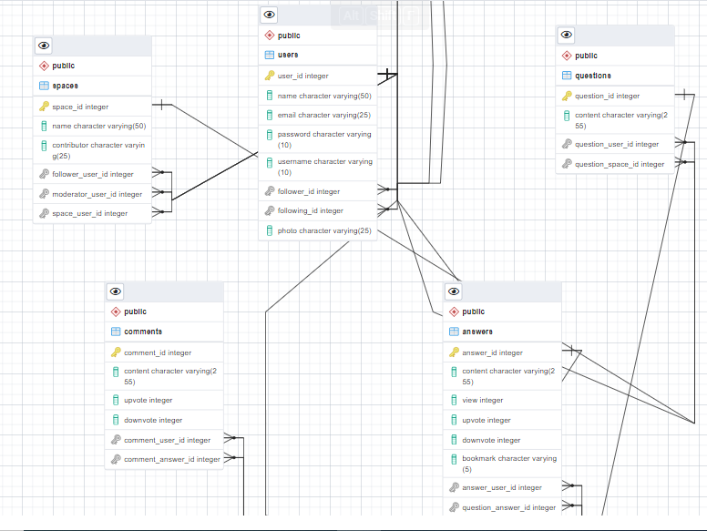

**Progress 9 Quora Database**

After I successfully created those tables, I inserted one data on each tables, so I can try to fetch the data on frontend. And then I have worked on backend on a spaces tables for testing purposes. I made controller, models and routers folder, so I can connect through index.js and test API through Postman.

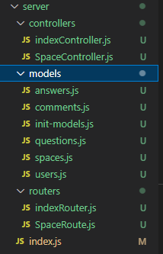

**Progress 10 Folders and Files Structure on Backend Server**

Good thing spaces’ find all function worked fine through Postman

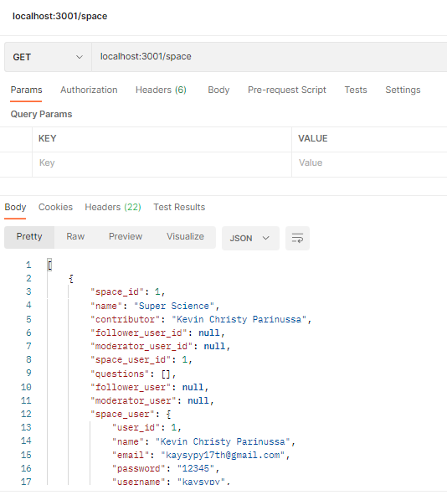

**Progress 11 Successful Testing On Postman**

**07/09/2022**

I have fetched and displayed data from spaces and answers table. I use mapping to display all data from reducer and dispatched it through useEffect. Now, for the answers, I displayed user’s name, credentials,photo and answer on the center of the home page. I haven’t worked on upvote,downvote, share and more sharing options buttons right below each answers. For spaces, I only dispatched 3 data from spaces table. I have changed some data type and added new columns on Quora database.

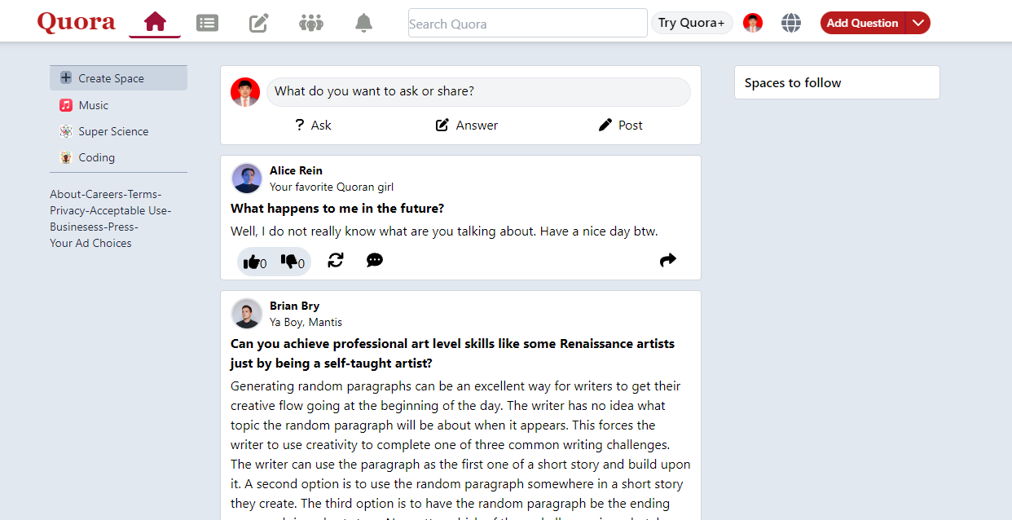

**Progress 12 Current Home Page With Displayed Data**

I also made the navigation bar to fixed position, so each time I scroll the navigation bar stay in place while the main page keep scrolling.

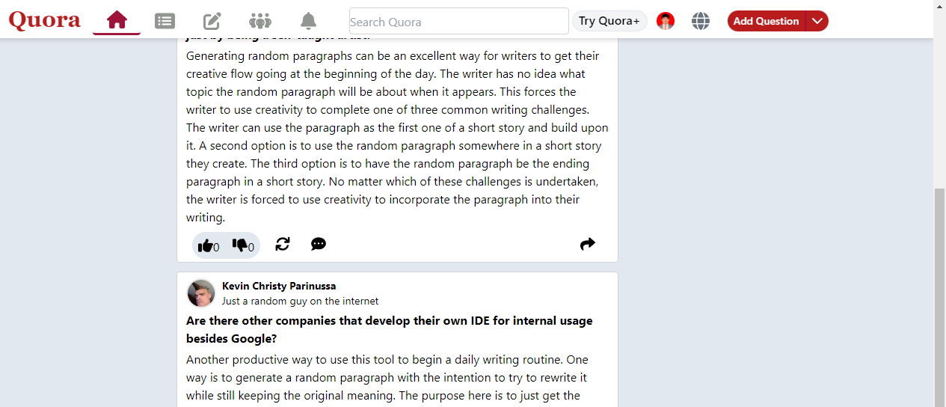

**Progress 13 Fixed Postion Navigation Bar**

**09/09/2022**

Now, my Quora React version’s homepage almost identical (minus the ad and messages) to Quora’s original homepage. There are some improvements I need to make in the future.

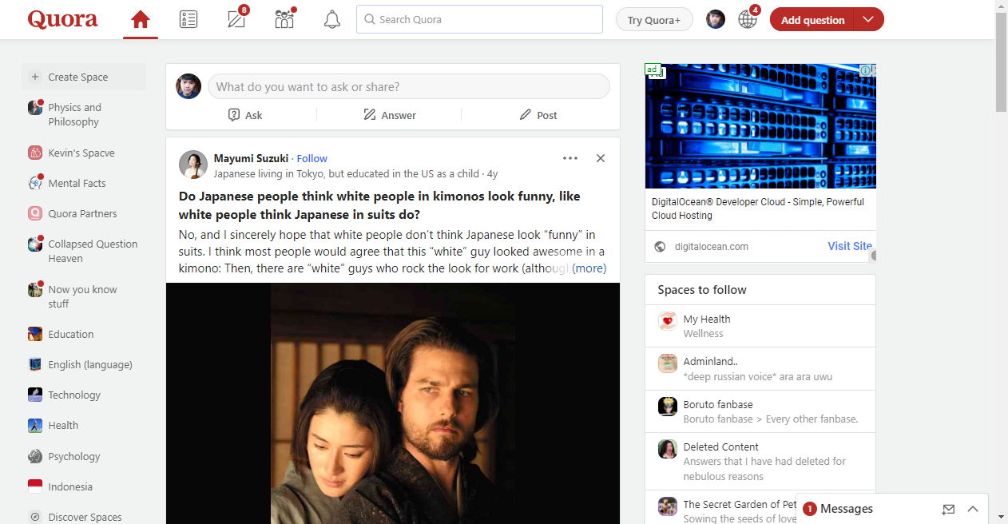

**Progress 14 Original Quora's Homepage**

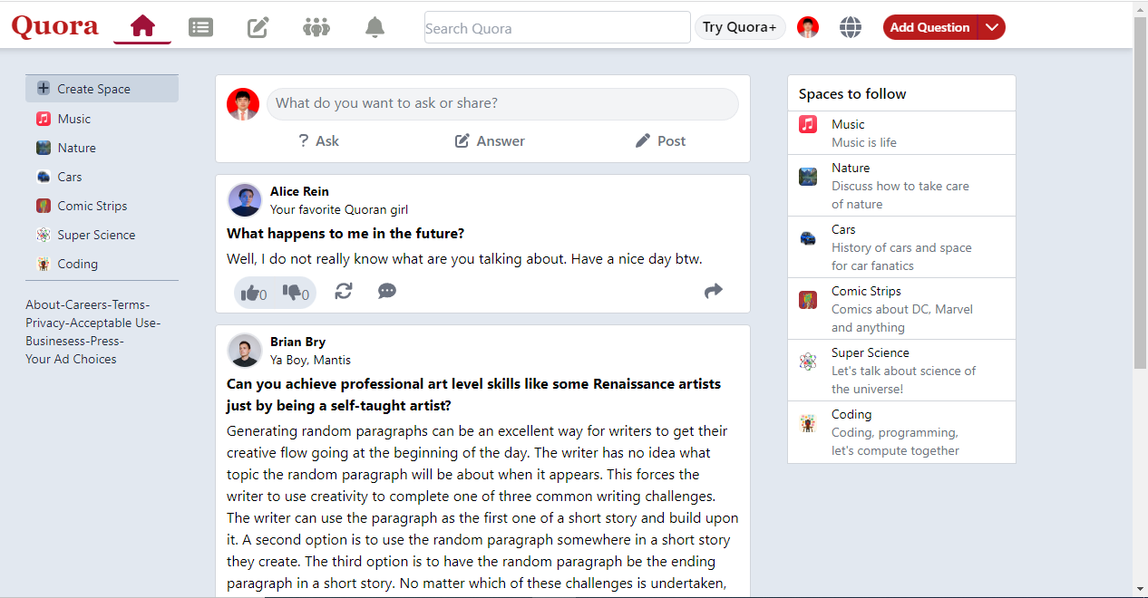

**Progress 15 My Quora's Homepage**

On the homepage, I only add spaces to follow, which contains some spaces that user haven’t followed. I also add Popover and Transition module from HeadlessUI. So, if I click one of the options below for example Nature, it will display a floating panel with content in it. On the panel there are space’s photo, name,details, follow, share and more buttons.

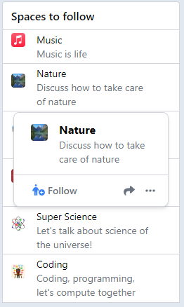

**Progress 16 Popover Feature On Spaces to Follow**

**15/09/2022**

All these days, I have learned a bit about Material UI usage and made a login page. I haven’t made all functions of it, but at least I have done the page’s appearance.

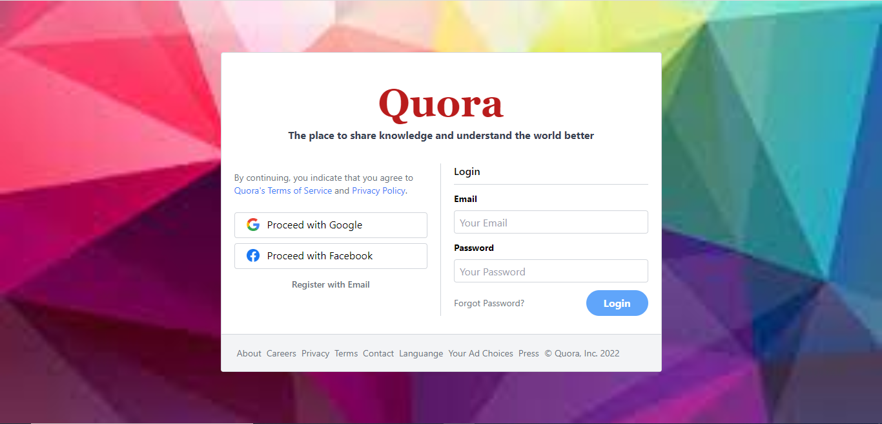

**Progress 17 Login Page**

And for Add Question button below, I made it with button module from MaterialUI. What make this hard is that MaterialUI modules is harder to style unlike when I used Tailwind CSS to style elements easily. I probably still not used to it. The button’s size is not matching the next button.



**Progress 18 MaterialUI Button For Modal Dialog**

But at the bright side, a modal dialog displayed successfully after I click Add Question button, even though I didn’t make any changes in it.

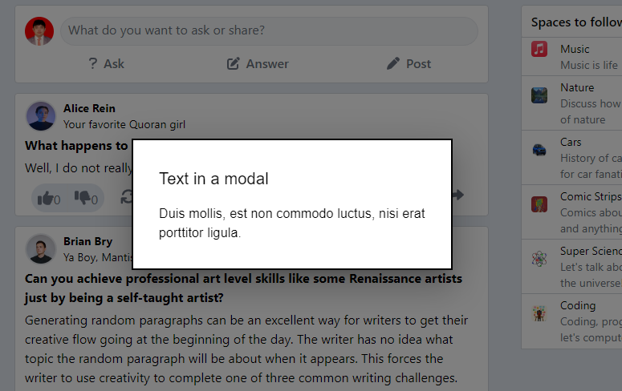

**Progress 19 Modal Dialog**

What I have done for the last 5 minutes, I add link to each navigation bar icons so the main page can change page based on own component.

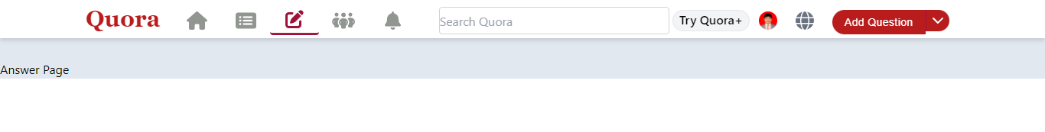

**Progress 20 Added Link to each icons**